 | الفصل التدريبي الثاني للعام 1442هـ | كلية الاتصالات والمعلومات بالرياض  قسم الحاسب والمعلومات  مقرر هندسة البرمجيات  Chapter2 Homework

الاسم: ...................عبدالله محمد الربيعان..................................... الرقم الأكاديمي: ...............441219721...................

Q1: Giving reasons for your answer based on the type of system being developed, suggest the most appropriate generic software process model that might be used as a basis for managing the development of the following systems:
- A system to control anti-lock braking in a car
The waterfall model / سبب اختار هذا النظام لان المطلوب واضح
- A virtual reality system to support software maintenance
Incremental development /سبب اختيار هذا النظم لاعطا المستخدم نسخه من العمل لكل فتره
- A university accounting system that replaces an existing system
Integration and configuration Based on software reuse / لان هو الانسب لاعادة نظام
- An interactive travel planning system that helps users plan journeys with the lowest environmental impact.
The waterfall model / سبب الاختيار لانه يبغا شي واضح
Answer:

Q2: Explain why incremental development is the most effective approach for developing business software systems. Why is this model less appropriate for real-time systems engineering?
Answer:

لانه مرن وغير واضح

Q3: Consider the reuse-based process model shown in Figure 2.3. Explain why it is essential to have two separate requirements engineering activities in the process.
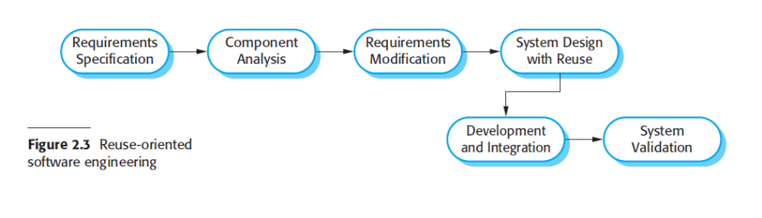
Answer:
نشوف المتطلبات القديمه ونحللها عشان تعرف المتطالبات الجديده

Q4: Suggest why it is important to make a distinction between developing the user requirements and developing system requirements in the requirements engineering process.
Answer:
يوجد اختلاف بين المستخدم والمتطلبات وينبغي النظر اليها بشكل تفصيلي

Q5: Describe the main activities in the software design process and the outputs of these activities. Using a diagram, show possible relationships between the outputs of these activities.
Answer:

مخرجات كل وحده هي مدخلات كل وحده

Q6: Explain why change is inevitable in complex systems and give examples (apart from prototyping and incremental delivery) of software process activities that help predict changes and make the software being developed more resilient to change.
Answer:
التغير في البزنيس و التطور في التكنولوجي

Q7: Explain why systems developed as prototypes should not normally be used as production systems.
Answer:

Throw away prototype

